# CHAPTER 4

# METHODOLOGY

This chapter details the methodology that was used to design a DDoS Protection System for Cloud Using AWS and Machine Learning. The approach involved the generation of synthetic traffic data, anomaly detection based on the Isolation Forest algorithm, and a robust cloud-based infrastructure that utilized AWS to manage traffic and auto-scale. It also involved stressing the system under simulated DDoS conditions using Apache JMeter and evaluating performance against key metrics such as anomaly detection accuracy, scalability of the system, and availability.

* 1. **Addressing Cloud Security Using AI and Cloud-Native Techniques**

This factor has made cloud infrastructure critical to businesses, hosting applications, and managing sensitive data. With the upsurge in the usage of cloud infrastructure, attacks by DDoS increase too. DDoS attacks present malicious traffic to overwhelm systems, which in turn disrupts service.

The proposed solution uses ML techniques in conjunction with cloud-native tools such as AWS Auto Scaling and Load Balancers and synthetic traffic simulations for real-time detection and mitigation of DDoS attacks. It focuses on an adaptive architecture that is scalable to achieve availability and performance under heavy traffic conditions.

# Synthetic Traffic Data Generation

A Python script was developed that simulates a realistic web traffic pattern, whether benign or malicious. It includes synthetic data such as:

* Normal traffic which mimics standard HTTP requests with a consistent interval and data sizes.
* Malicious traffic: Simulates DDoS-like behavior, including sudden spikes in requests and high-frequency traffic from multiple sources.

These parameters include request rate, traffic distribution, and payload size to create diverse datasets. These datasets will be used to conduct anomaly detection. Log and save the traffic patterns. It is necessary for later pre-processing and analysis.

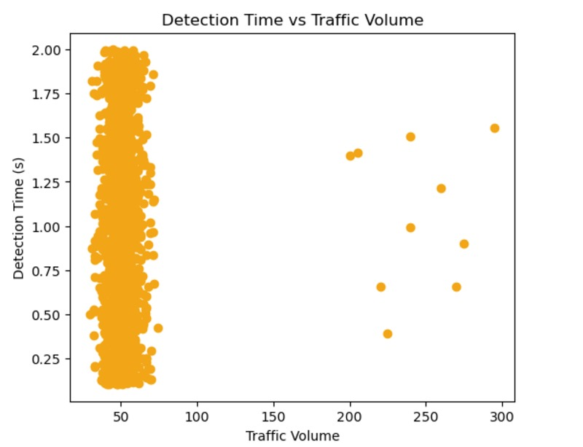

Fig. 4.1 Detection Time vs Traffic Volume

# Anomaly Detection with Machine Learning

The Isolation Forest algorithm was employed with the scikit-learn library to determine anomalies in traffic data. This algorithm isolates anomalies by recursively partitioning the dataset; hence it is very suitable for identifying anomalous traffic patterns. The process encompasses the following steps:

* Preprocessing the data: Standardization of request frequency, payload size, and response times.
* Training the model: Synthetic traffic data was used to train the Isolation Forest to classify traffic as either benign or suspicious.
* Visualization: The model identified outliers were visualized with Matplotlib that gave the suspicious activity insights.

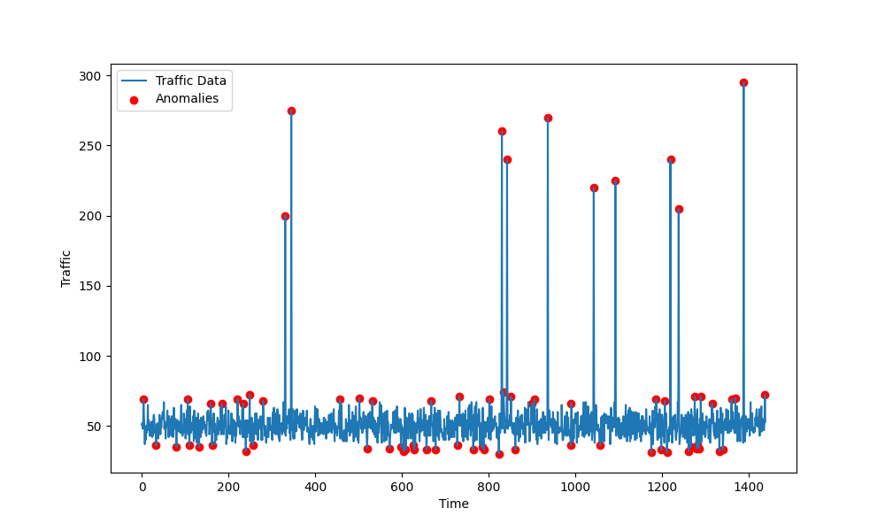

Fig. 4.2 Anomalies Detection Plot

# Load Testing with Apache JMeter

* + 1. **Simulation of realistic traffic**

We used the Apache JMeter tool for stress testing our system under the following traffic scenarios, in order to emulate real attacks:

* Number of users: Simulated concurrent requests by multiple sources
* Ramp-up period: Gradually increasing traffic with respect to time.
* Loop count: Continuous sending of requests simulating persistence DDoS attack behavior.

These parameters enabled all possible tests that could prove the system's response for normal and malicious loads.

## DDoS attack resilience tests

Tests created in JMeter aimed at testing the system's resiliency to sudden increases in traffic. Response time, throughput, and error rate metrics were used to establish how effective the system was in withstanding stress conditions.

# Cloud Integration with AWS

## Deploying on AWS

The anomaly detection script and traffic monitoring components were deployed on an AWS EC2 instance. This cloud-based setup enabled real-time detection and monitoring of incoming traffic.

## Traffic Monitoring with CloudWatch

Amazon CloudWatch was configured to track key performance metrics, including:

* NetworkIn: Monitors incoming traffic volume.
* CPU utilization: Tracks server load under varying traffic conditions.

CloudWatch alerts were set to notify administrators whenever thresholds were being breached, so responses in case of potential DDoS attacks could be expedited.

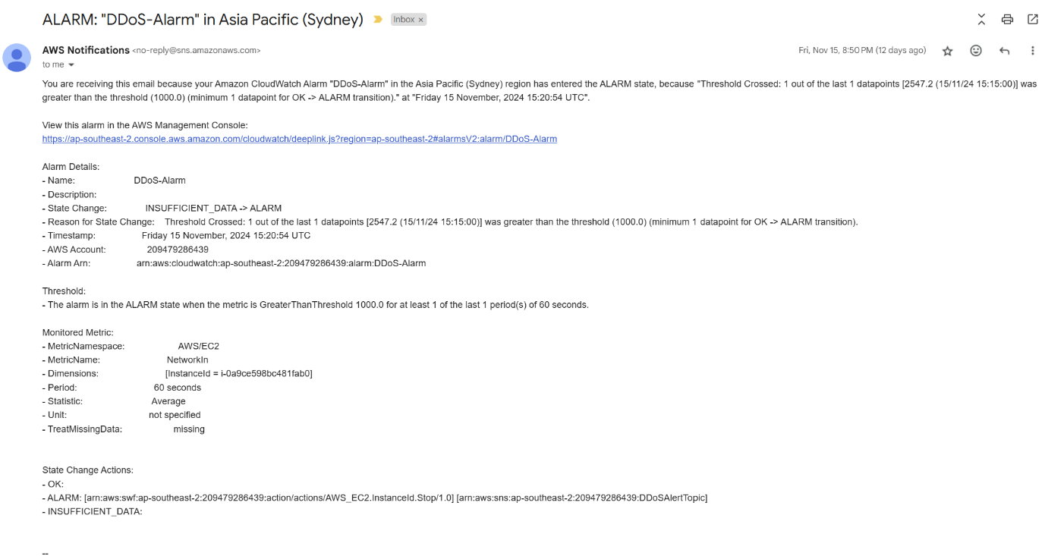

Fig. 4.3 Alert Email Screenshot

## Auto Scaling and Load Balancing

To ensure scalability and availability of the system:

* AWS Auto Scaling will dynamically adjust the number of EC2 instances depending upon the incoming traffic load; these instances scale up during peak usage and scale down during normal usage.
* An AWS Elastic Load Balancer (ELB) distributed incoming traffic evenly across instances, preventing overload on any single server and maintaining service continuity.



Fig. 4.4 Auto Scaling Behavior

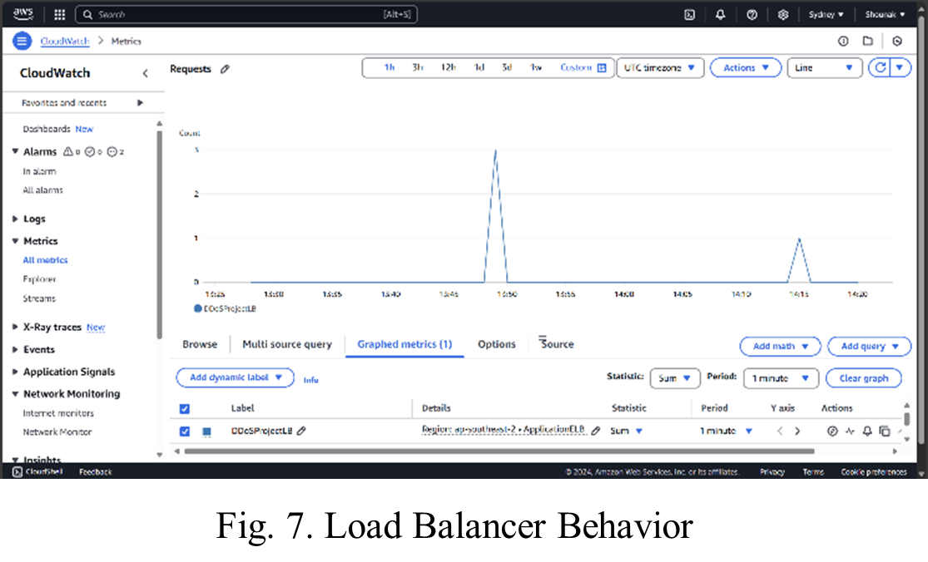

Fig. 4.5 Load Balancer Behavior

# Validation and Mitigation Strategies

* + 1. **Simulation of Attack Scenarios**

Several attack scenarios were simulated using JMeter to validate the system's ability to:

* Detect anomalies in real-time using the Isolation Forest algorithm.
* Scale resources dynamically to handle traffic surges.
* Maintain availability during DDoS attacks.
  + 1. **Mitigation with Blocking Mechanisms**

Automated blocking mechanisms were put in place based on the detection of suspicious activity to:

* Restrict traffic from identified malicious IP addresses.
* Maintain normal traffic flow and minimize disruption.
  + 1. **Performance Evaluation**

The performance of the system was measured using metrics like:

* Detection accuracy: Capability to correctly identify malicious traffic.
* Scalability: How well Auto Scaling keeps up with performance under loads.
* Availability: Percentage uptime during stress conditions.

Improvements in detection algorithms and architectures were made based on the feedback from the evaluations.

* 1. **Summary**

This methodology outlines a comprehensive approach to DDoS protection using synthetic traffic generation, machine learning for anomaly detection, and AWS for scalability and resilience. By integrating these components, the system effectively addresses the challenges posed by DDoS attacks, ensuring continuous availability and performance in cloud environments.